Responses to your Questions
- There also seems to be a problem with phase two. The participant should press the space bar when the light is on but then suddenly two items appear on the screen in succession. This should not be. I need to try this a bit more to find out what exactly the problem is. Perhaps we need to widen the time interval between the two colours. I need to check this further.
—> I noticed this as well, this is due to the loading delay of the images. I know how to fix it
Great!
- Regarding never-ending Category tiles: I’m not aware of a way to make the tiles never-ending. I can only extend the number of tiles to make it “seem” never-ending (for now, if this is really important, I can look into it further). However, it should not end on a row with a single tile, as you have shown in your screenshot, it should end on a full row and I would fix this to begin with. Let me know what you think.
This was an issue that we discussed many times but never clarified. What I mean by never-ending is that we show all the categories in pseudorandom order (pseudo because 20% categories on the screen should always be drug-related). Once all categories have been shown, you start again with the ones shown at the beginning, so that the participants can scroll and scroll but never reach an end. Does this make sense?
Follow-up Questions
- We should think of a rule that a certain percentage of tiles (perhaps 10-20%) should display tiles of the drug-related category but in a mixed fashion (mixed in terms of alcohol and drugs) —> Could you explain what you mean? Currently, around 2 tiles per row are always drug tiles.
My screen shows 35 tiles of categories on the screen, which should be selected pseudo randomly from our category lists, i.e. 75-80% neutral items, and 20-25% drug-related items. For my screen this would mean that 7 categories are drug related.
For the first screen, cocaine or crack should always be amongst the categories that participants see when they start the task.
- The first question does not seem to take the answer. If you click an option, it does not show —> Are you sure? As per our discussion, I made the slide transition instantly after clicking. So you do not see which box you ticked, but it should be registered. I could however add a delay, as we did for the category and item tiles?
I have just tried this again. I started the task and picked headphones, then I see lots of tiles, I click on one (at the bottom), see the item and click back. Then the item does not display. It still looks as if I have not selected anything.
Then, I opened a second tile, ….everything as before – click back, and then, I see the item displayed on the screen.
This only seems to happen sometimes with the first item selected.
Second up: I don't think it is realistic for me to implement all the changes you have suggested by Monday. If you are meeting Trevor on Monday, I would propose that you could go over the list (ideally today, if you are still in) and rate them on a three-point rating scale:

Most important changes:

Data-Entry
- Warning for duplicate ID Entry
Slide-View (and Experiment)
- Remove Next-Button from the VAS, and instead, move on instantly after making a response
- No feedback to clicking first question (shopping frequency) – Sorry, this is not quite right. We do want participants to see what they have clicked; so yes, please show the tick.
Shop
- Category Tiles
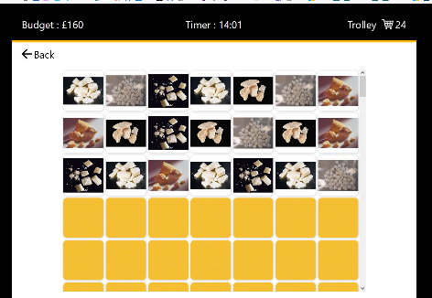
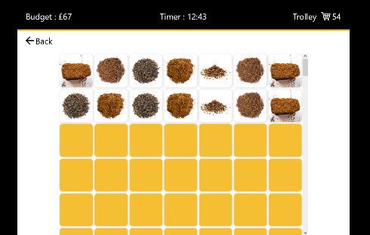
  - All items should be shown, not just 5 items per category!
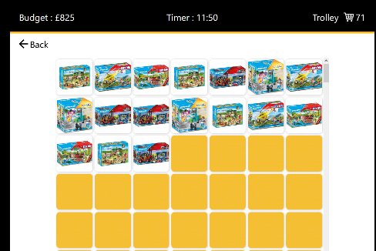
  - Consistent Capitalization in category name
  - Cat Accessories → Cat over Accessories
  - To Go into Mugs to go
  - Remove Cannabis and Vapin (vapin does not make sense, we have the category vapes)
  - Rename the Garden category to Garden Accessories
  - Hookah, Hashish, Cannabis, Cannabis products, Vapin, and Prosecco are empty – need to be filled with items.
  - Category tile display should not end on a single tile

- Item Tiles
  - First item that participant selected is not displayed when participant clicks (back or to trolley), only the second item they picked is displayed.
  - Bug: Automatic scrolling to the top of the page sometimes when participants click a tile (should not have to scroll back)
  - Check if items repeat earlier than expected ( example: crack image ) – all items of one category should be opened first before they repeat; when they repeat, the last 5 items opened are blocked for repetition to make it less obvious that these are repeats.
- Budget
  - Budget should go down when participants select an item. However, when they select an item that costs more than their budget, they receive a £1000 gift – so far all is correct. However, when the task resumes, the item that they selected has not been deducted from their budget. So you need to subtract this from their old and new budget.
- Trolley
  - When participants look into their trolley, the layout does not show the trolley icon in the right-hand corner anymore (see below). Please include the trolley icon and the number of items in the trolley. Then, when participants tick on an item to remove it, the item count (right-hand corner) should go down.
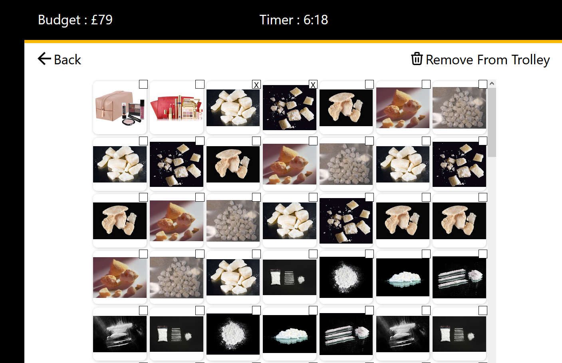
  - Please replace the bin icon with a box ticked icon. Do not capitalise every word. It should read: Remove from trolley.

- Randomization
  - Cannabis is shown twice right above each other (category should be pseudo randomly shown on the screen but not duplicated before all categories have been shown)
  - Some Drugs appear more often than others (Prosecco all the time, Cigars hard to find) – all drugs should be presented equally often
- Slides
  - The alarm clock waring slide has no sound.
  - Alarm clock warning should be introduced earlier (no item in under 5 minutes, less than 10 items in under 8 minutes)
Phase 2
- Time between lights needs to be extended. I think at the moment the time frame is 500 – 700 ms for the light bulb to turn blue or orange. That’s fine but there needs to be variable period between the two lights too, perhaps as well 500 – 700 ms. This is to avoid confusion. The participant needs time to press the button before the new light shows up.
- Two items from the same trolley should not be shown in succession.
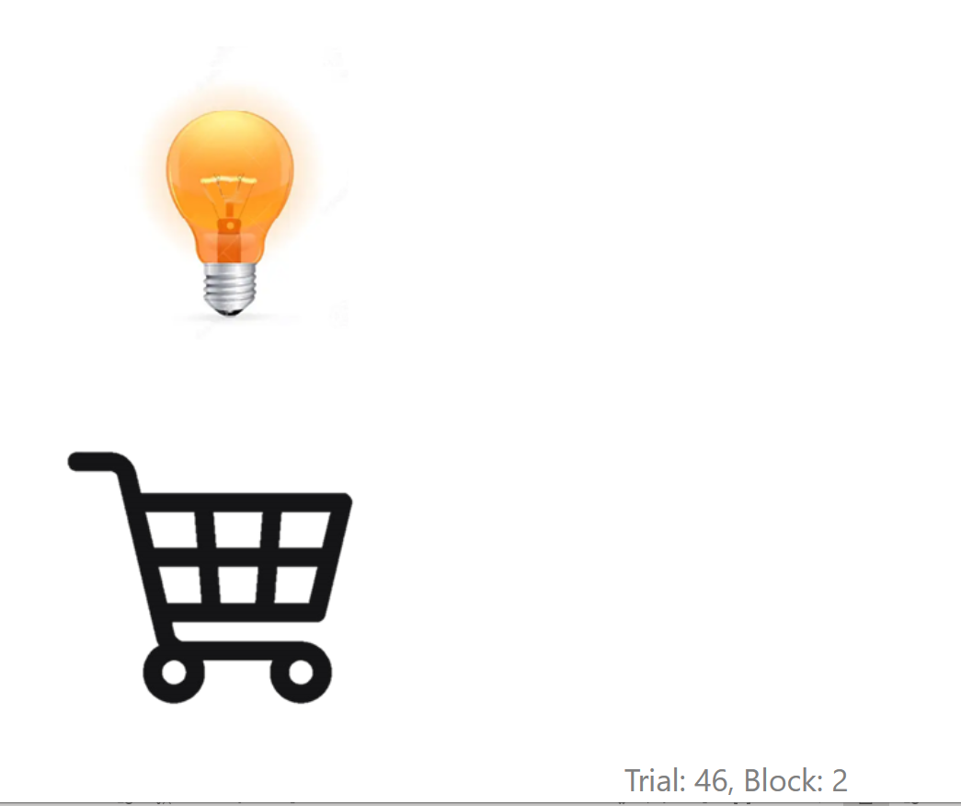
- Remove trial information from right bottom corner.
- Both lights should be shown equally often
- When participants are successful in claiming an item, then a positive sound should appear.
- Other items (items from other participants) should not include drug-related items or books relating to drugs or alcohol.
- Ratings should be introduced with a ding dong (sound).
- All items from the trolley should be shown first before they are repeated. This also applies to other customers’ trolleys.
- An item should never be repeated immediately.
Phase 3 – should be implemented.
- Sound for wrong answer.
- Sound for correct answer.
- Sound for all correct.
- Remove Next button from the table.
- Phase 3 should be fully implemented, i.e. participants should see the shop, have a budget of £1000 and timer should be set to 5 minutes.
- After 5 minutes, participants should see the “Time is up” side and then be informed that their items are now being dispatched (similar to end of phase 1).
If anything is missing, feel free to add and rate according to the colour scheme.

IMPORTANT PROBLEM TO FIX: auditory feedback in phase 2

The auditory feedback should be associated with a successful button-press, not with free rewards! Free rewards are only accompanied by positive visual feedback.

The questions about the light bulb – trolley associations are missing after the first block of phase 2.

It would be good to include the Hashish category (see attachment).

I also attach the other sounds:
- Warning: alarm clock sound (phase 1)
- Congratulations for lucky customers (phase 1) – new sound.
- End of phase 1 – new sound
- Introduction to first rating in between blocks – you have done this already
- End of phase 2 - new sound (when well done is shown)
- Correct choice memory task (phase 3) – please use the new sound attached
- Wrong choice memory task (phase 3) – please use the new sound attached
- All correct in memory task (phase 3) – please use the new sound attached

Please find attached the slides that should not have a next button.

We need to revisit the alarm clock warning.
Rule phase 1
- No item selected within the first 5 minutes.
- Less or 10 items selected after 10 minutes.

Rule phase 3:
- No item selected after 2.5 minutes

I think I have identified the problem with the first selection; the computer displays the first item selected randomly on the matrix, not at the place where the participant opened the first time. This is why it looks as if nothing has happened. Something did happen but it does not show.

The memory check slide should not have a NEXT button. The logic is the following:

- Participants should tick the gift that they should get for the different people.
- When they make the right choice, they get positive auditory feedback, and the tick stays on the screen.
- When they make an error, they get negative auditory feedback, but the tick does not stay on the screen.
- When they get all the answers right, they receive the “all correct” auditory feedback while the slide is on the screen so that the participant could look at the correct answers while the fanfare is playing. Then the next slide is shown (no next button!).

You may not have fixed the problem with the repetition yet because items seem to repeat before all items had been shown (see example below).

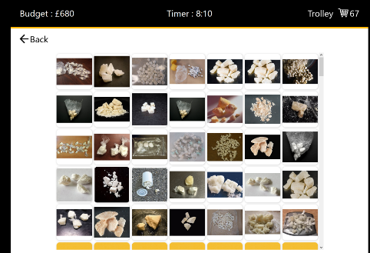

Please change the order of slides at the end of phase 3:

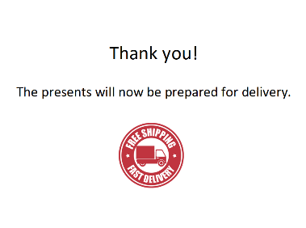
No NEXT button!
Shown for 2 seconds only.

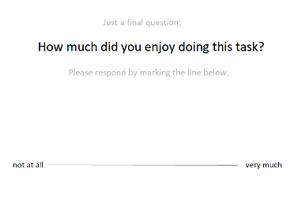
No NEXT button!
Slide disappears when participant makes a response.


Stays on the screen until the researcher presses escape.

